 

INSTITUTE FOR ADVANCED COMPUTING AND SOFTWARE DEVELOPMENT AKURDI, (IACSD) PUNE.

Documentation On

“**TASTY-TREAT ONLINE FOOD PORTAL**”

***PG-DAC SEPTEMBER 2022.***

*Submitted By:*

**Group No: 61**

# Suraj Jadhavar (229222)

# Atharva Bibikar (229137)

**Mrs. Manjiri Deshpande Mr. Rohit Puranik**

**Project Guide Centre Coordinator**

**ABSTRACT**

Tasty-Treat Online Food Delivery is a basic one stop web application for customers, hotel managers & delivery executives. Customers can order available food from their favorite restaurants whereas the restaurants can decide which food from their restaurant is been made available for their customers under specific food categories. The restaurant managers can assign the food orders to the delivery executives and the delivery executives can deliver the food order and notify about delivery status.With the help of this system, people can easily order the food. It can also ensure that the people do not waste their precious time and use their time productively in the other works. In long run, this will ensure that it helps to reduce labour cost. This system proves to be more cost effective and reliable over other systems.

# ACKNOWLEDGEMENT

I take this occasion to thank God, for blessing us with his grace and taking our endeavor to a successful culmination. I extend my sincere and heartfelt thanks to our esteemed guide, **Mrs. Manjiri Deshpande** for providing me with the right guidance and advice at the crucial juncture sand for showing me the right way. I extend my sincere thanks to our respected Centre Coordinator **Mr. Rohit Puranik** for allowing us to use the facilities available. I would like to thank the other faculty members also, at this occasion. Last but not the least, I would like to thank my friends and family for the support and encouragement they have given me during the course of our work.

Suraj Jadhavar (229222)

Atharva Bibikar (229137)

# Table of Contents

1. Introduction 1

Problem Statement 1

Aim & Objectives 1

1. Overall Description 2

Proposed Methodology 2

Operating Environment 2

Design and Implementation Constraints 3

1. Requirements Specification 4

External Interface Requirements 4

1. System Diagram 8

Activity Diagram 8

Data Flow Diagram 9

Class Diagram 13

Use Case Diagram 14

ER Diagram 15

1. Table Structure 17
2. Screenshots 20
3. Conclusion 25

Future Scope 25

1. References 26

**List of Figures**

Figure 1 Customer Activity Diagram 8

Figure 2 Restaurant Manager Activity Diagram 9

Figure 3 Delivery Person Activity Diagram 10

Figure 4 Level 0 Data Flow Diagram 11

Figure 5 Level 1 Data Flow Diagram 12

Figure 6 Level 2 Data Flow Diagram for Customer 12

Figure 7 Class Diagram 13

Figure 9 Use Case Diagram 14

Figure 10 ER Diagram 15

Figure 11 System Generated ER Diagram 16

**Introduction:**

# INTRODUCTION.

Tasty-Treat food is a web application that provides the function and features to authenticate and identify the customers (users), restaurant managers and delivery persons. Portal provide user with easy, personalized web-interface for facilitating access to restaurant information and food services that are of primary relevance and interests to the users. Tasty-Treat food Portal is nothing but a portal which thinks customers as the main target users and provides so many useful services to customers at a single place. It helps to deliver various cuisine from various restaurant to customers with the help of delivery person.

## Problem Statement:

There are many problems found in the today’s food portal system. The problems created in the existing system enforced us to develop the new system which minimize the problem of the existing system. The problems are Low quality of food, Unhygienic kitchen and lack of inclusion of all type of food. Its application depends on location of the customer and location of restaurant.

## Aims and Objective:

The main purpose of this system, is to increase the awareness about various food available in an area. To make cross cultural awareness among the people and to generate the feeling of oneness. Provide on time delivery of foods. In other words, our Tasty-Treat food portal has, following objectives:

* Simple database is maintained.

* Easy operations for the operator of the system.

User interfaces are user accommodating and attractive; it takes very less time for the customer to use the system.



*Easy operations for the operator of the system.

**Proposed Methodology:**

# OVERALL DESCRIPTION.

This system provides an easy way for customers to view and order the various cuisines. Restaurant staff to manage their food orders and deliver the food with help of delivery persons. The online food portal enables restaurants (system user) to showcase their cuisines online, customers to browse through portal can buy the food. This product aimed towards a person who don’t want to visit the restaurants but want to taste the food in his home or office etc. She/he can use the web application for ease.

## Operating Environment:

Server Side:

**Processor:** Intel® Core i5 8th Gen

**HDD:** Minimum 1TB Disk Space

**RAM:** Minimum 8GB **OS:** Windows 10, Linux 6 **Database:** MySQL

Client Side (minimum requirement):

**Processor:** Intel Dual Core

**HDD:** Minimum 500GB Disk Space

**RAM:** Minimum 4GB

**OS:** Windows 10, Linux

**Browser:** Chrome /Edge/ Mozilla Firefox, etc. (Latest version)

## Design and Implementation Constraints:

* The application will use React JS as frontend and Java spring Boot API as a backend.
* The application will use JavaScript, HTML and CSS as web technologies.
* HTTP and FTP protocols are used as communication protocols. FTP is used to upload the web application in live domain and the client can access it via HTTP protocol.
* SMTP protocol is used for Email communication.
* Several types of validations make this web application a secured one and SQL Injections can also be prevented.
* Since Tasty-Treat Online Food Portal is a web-based application, internet connection must be established.
* The Tasty-Treat Online Food Portal will be used on PCs and will function via internet or intranet in any web browser.

**External Interface Requirements:**

# Requirements Specification.

User Interfaces:

* 1. All the users will see the same page when they enter in this website. This page asks the users a username and a password.
  2. After being authenticated by correct username and password, user will be redirect to their corresponding profile where they can do various activities.
  3. The user interface will be simple and consistence, using terminology commonly understood by intended users of the system. The system will have simple interface, consistence with standard interface, to eliminate need for user training of infrequent users.

Hardware Interfaces:

* 1. No extra hardware interfaces are needed.
  2. The system will use the standard hardware and data communication resources.

This includes, but not limited to, general network connection at the server/hosting site, network server and network management tools.

Application Interfaces:

**Web Browser:**

The system is a web-based application; clients need a modern web browser such as Mozilla Firebox, Internet Explorer, Opera, and Chrome. The computer must have an Internet connection in order to be able to access the system.

Communications Interfaces:

* 1. This system uses communication resources which includes but not limited to, HTTP protocol for communication with the web browser and web server and TCP/IP network protocol with HTTP protocol.
  2. This application will communicate with the database that holds all the Orders

Information. Users can contact with server side through HTTP protocol by means of

a function that is called HTTP Service. This function allows the application to use the data retrieved by server to fulfil the request fired by the customer.

**Functional Requirements:**

* Access Website :

User should be able to access web-application through either an application browser or similar service on the mobile phone or computer.

* Registration :

Given that user and admin has accessed web-application, then both should be able to register through the web-application. The user must provide first name, last name, email, contact number, username and password.

* View Profile: In which user and admin can see their current profile status.
* View Product Details & add to cart:

Users can see the product details by login to the web application. e.g., Product category, Product items, Quantity, etc.

* User log-in:

Given that the user has registered, then the user should be able to login to the web-application. The login information will be stored on the database for future use.

* Search product in product list:

Specific product can be viewed in the product list. Users can search product by using product category.

* Update product in product list:

Restaurant Manager can update their food products as well as add new Products. Also can give discount and Offers to Products. Specific product can be viewed in the product list.

* Assign Delivery:

Restaurant Manager can assign delivery to delivery person as per customer order.

* Deliver Food order to Customer:

Delivery person delivers order to particular customer as assigned by restaurant manager

**Non-functional Requirements**

* Security

The system’s back-end servers shall only be accessible to authenticated administrators. Sensitive data will be encrypted before being sent over insecure connections like the internet.

* Availability

The system should be available at all times, meaning the user can access it using a web browser, only restricted by the downtime of the server on which the system runs. In case of an of a hardware failure or database corruption, a replacement page will be shown. Also, in case of a hardware failure or database corruption, backups of the database should be retrieved from the server and saved by the administrator. Then the service will be restarted. It means 24 X 7 availability.

* Reliability

The reliability of the overall program depends on the reliability of the separate components. The main pillar of the reliability of the system is the backup of the database which is continuously maintained and updated to reflect the most recent changes. Thus, the overall stability of the system depends on the stability of container and its underlying operating system.

* Maintainability

A commercial database is used for maintaining the database and the application server takes care of the site. In case of a failure, a re-initialization of the program will be done. Also, the software design is being done with modularity in mind so that maintainability can be done efficiently.

* Accessibility

The system will be a web-based application it is going to be accessible on the web browser.

* Back up

We will take a backup in our system database. In order to enable the administrator and the user to access the data from our system.

* Performance

The product shall be based on web and has to be run from a web server. The product shall take initial load time depending on internet connection strength which also depends on the media from which the product is run. The performance shall depend upon hardware components of the client/customer.

* Supportability

The source code developed for this system shall be maintained in configuration management tool.

**Features**

* Password Encryption

Encrypted password saved in database after successful sign up by customer (Serialization) and automatically decrypted while sign in (De-Serialization)

* Email Notification

Customer receives welcome email on sign up.

* Role Based User Functionality

Restaurant Manager, Customer and Delivery Person have different functionalities in the same application.

# System Diagrams.

## Activity Diagram:

*Customer Activity:

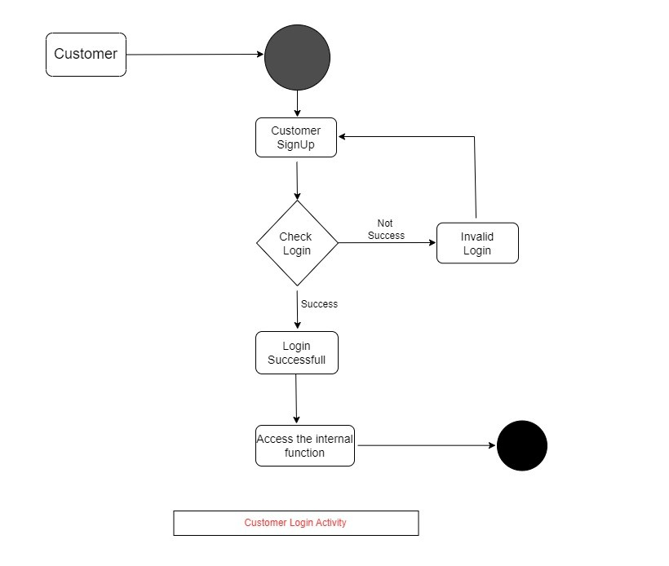

*Restaurant Manager Activity:

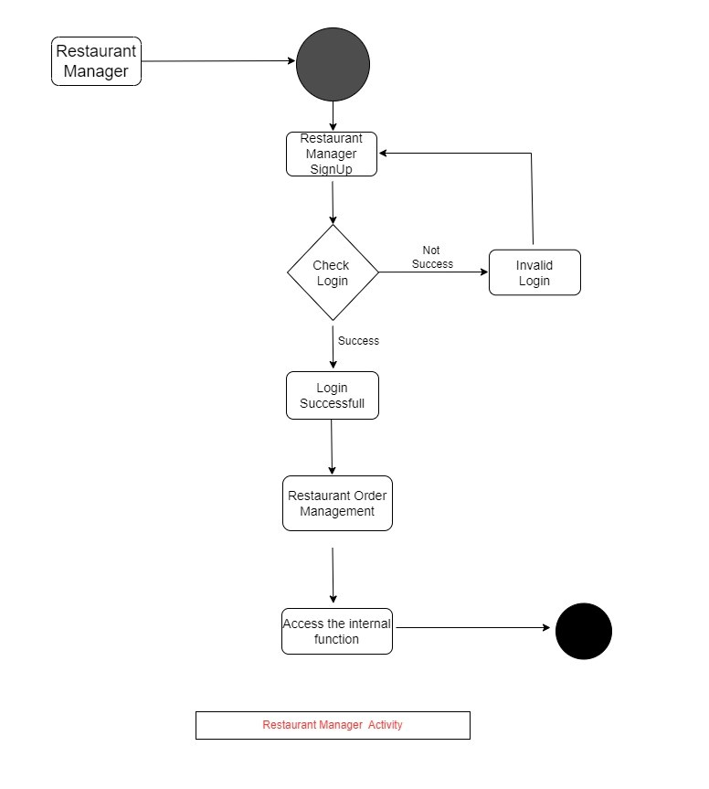

*Delivery Person Activity:

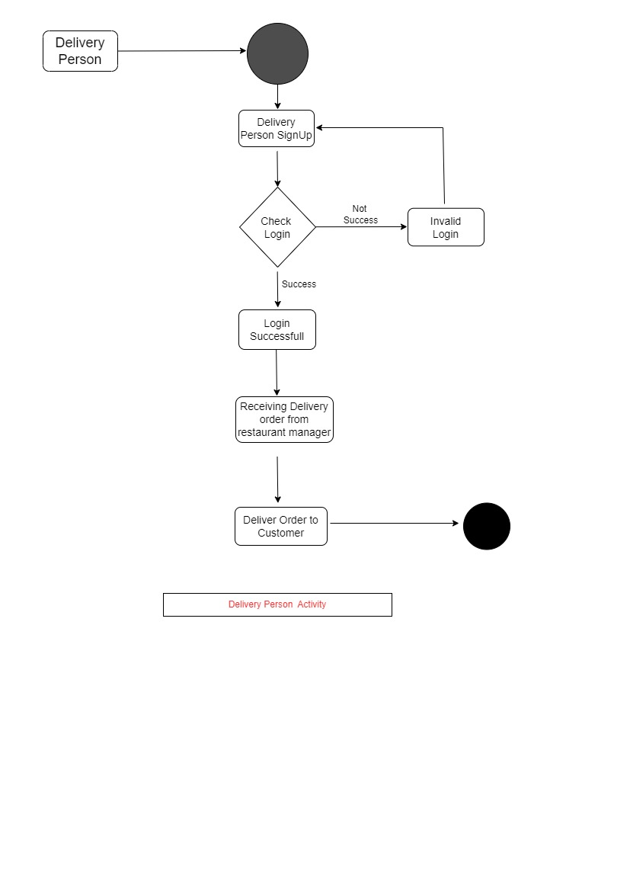

## Data Flow diagram:

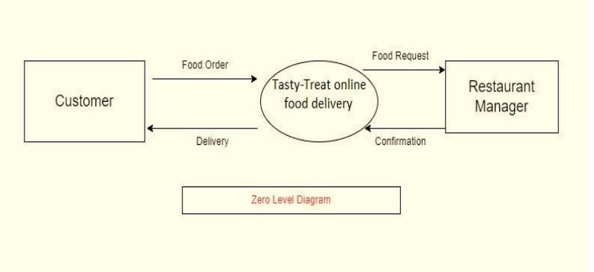

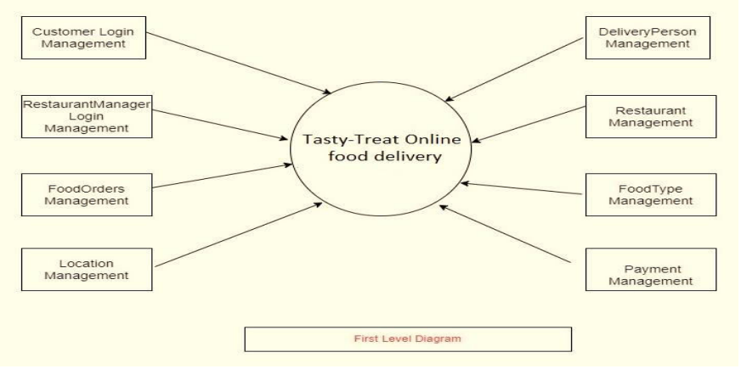

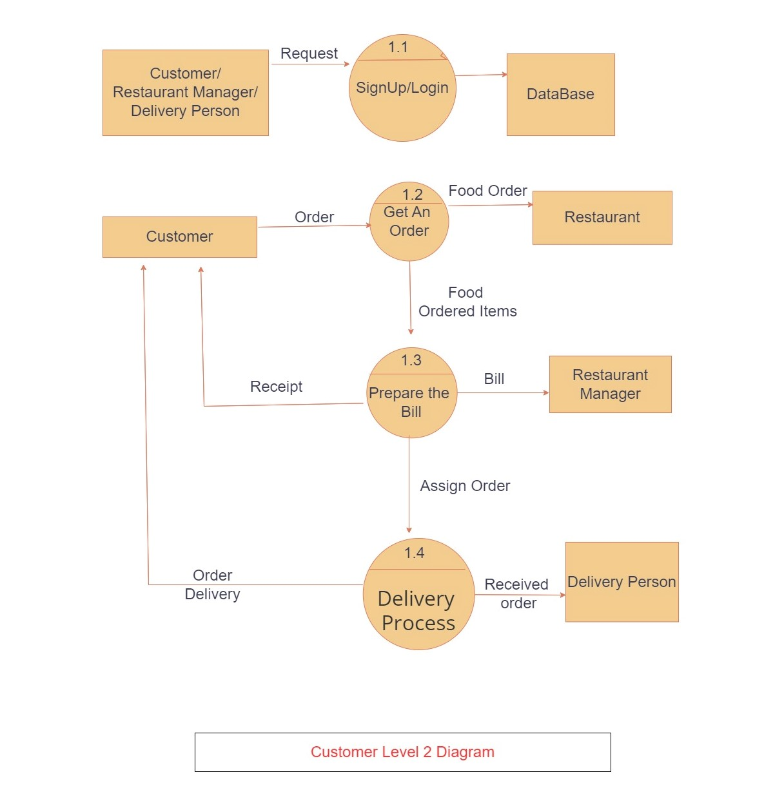

## Class Diagram:

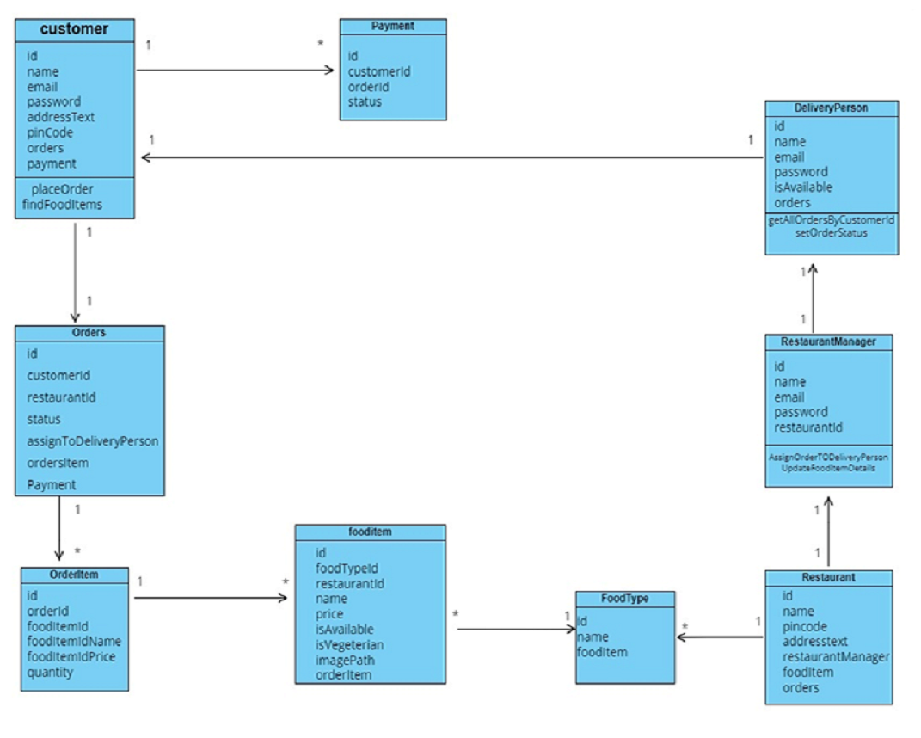

## Use Case Diagram:

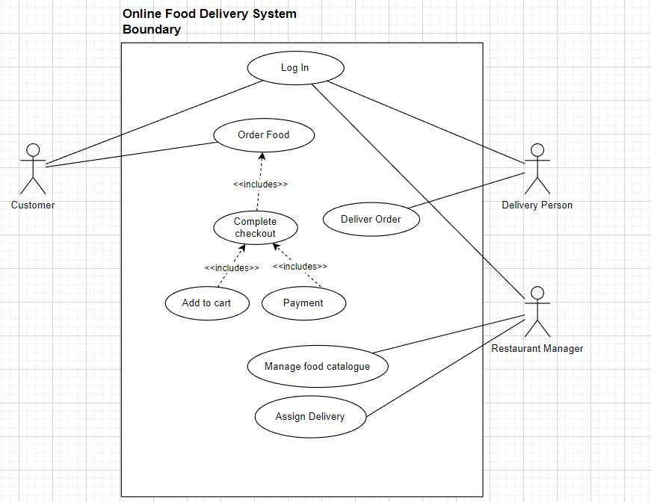

## ER Diagram:

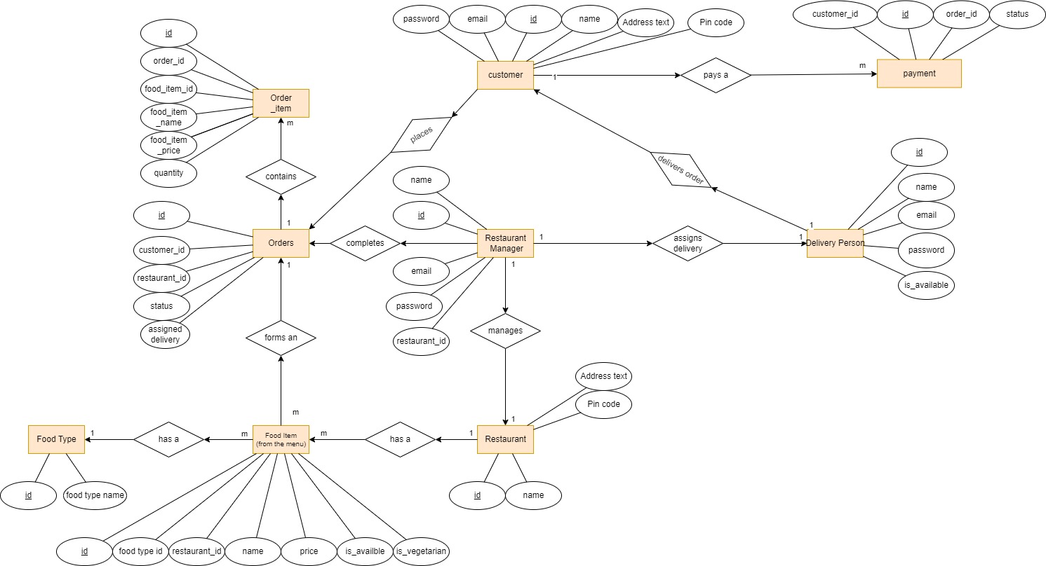

* 1. **System generated ERD**

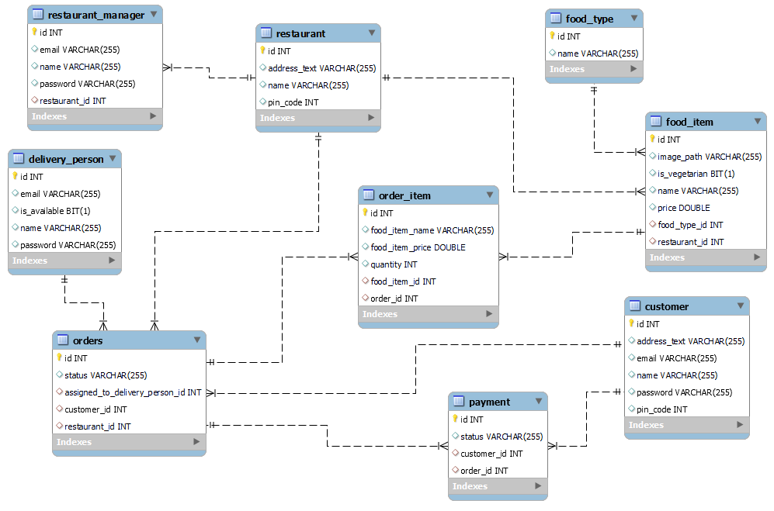

# Table Structure.

* 1. customer:

|  |  |  |  |  |  |
| --- | --- | --- | --- | --- | --- |
| Field | Type | Null | Key | Default | Extra |
| id | int | NO | PRI | NULL |  |
| Address_text | varchar(255) | YES |  | NULL |  |
| email | varchar(255) | YES |  | NULL |  |
| name | varchar(255) | YES |  | NULL |  |
| password | varchar(255) | YES |  | NULL |  |
| Pin_code | varchar(255) | YES |  | NULL |  |

* 1. delivery-person:

|  |  |  |  |  |  |
| --- | --- | --- | --- | --- | --- |
| Field | Type | Null | Key | Default | Extra |
| id | int | NO | PRI | NULL | auto_increment |
| email | varchar(255) | YES |  | NULL |  |
| Is_available | bit(1) | YES |  | NULL |  |
| name | varchar(255) | YES |  | NULL |  |
| Password | varchar(255) | YES |  | NULL |  |

* 1. food item:

|  |  |  |  |  |  |
| --- | --- | --- | --- | --- | --- |
| Field | Type | Null | Key | Default | Extra |
| id | int | NO | PRI | NULL | auto_increment |
| Image_path | varchar(255) | YES |  | NULL |  |
| Is_available | bit(1) | YES |  | NULL |  |
| Is_vegeterian | bit(1) | YES |  | NULL |  |
| name | varchar(255) | YES |  | NULL |  |
| price | double | YES |  | NULL |  |
| food_type_id | int | YES | MUL | NULL |  |
| restaurant_id | int | YES | MUL | NULL |  |

* 1. food type:

|  |  |  |  |  |  |
| --- | --- | --- | --- | --- | --- |
| Field | Type | Null | Key | Default | Extra |
| id | int | NO | PRI | NULL | auto_increment |
| Image_path | varchar(255) | YES |  | NULL |  |

* 1. order_item:

|  |  |  |  |  |  |
| --- | --- | --- | --- | --- | --- |
| Field | Type | Null | Key | Default | Extra |
| id | int | NO | PRI | NULL | auto_increment |
| Food_item_name | varchar(255) | YES |  | NULL |  |
| Food_item_price | double | YES |  | NULL |  |
| quantity | int | YES |  | NULL |  |
| Food_item_id | int | YES | MUL | NULL |  |
| order_id | int | YES | MUL | NULL |  |

* 1. orders:

|  |  |  |  |  |  |
| --- | --- | --- | --- | --- | --- |
| Field | Type | Null | Key | Default | Extra |
| id | int | NO | PRI | NULL | auto_increment |
| status | varchar(255) | YES |  | NULL |  |
| Assign_to_delivery_person_id | int | YES | MUL | NULL |  |
| customer_id | int | YES | MUL | NULL |  |
| restaurant_id | int | YES | MUL | NULL |  |

* 1. payment:

|  |  |  |  |  |  |
| --- | --- | --- | --- | --- | --- |
| Field | Type | Null | Key | Default | Extra |
| id | int | NO | PRI | NULL | auto_increment |
| status | varchar(255) | YES |  | NULL |  |
| customer_id | int | YES | MUL | NULL |  |
| order_id | int | YES | MUL | NULL |  |

* 1. restaurant:

|  |  |  |  |  |  |
| --- | --- | --- | --- | --- | --- |
| Field | Type | Null | Key | Default | Extra |
| id | int | NO | PRI | NULL | auto_increment |
| Address_text | varchar(255) | YES |  | NULL |  |
| name | varchar(255) | YES |  | NULL |  |
| pin_code | int | YES |  | NULL |  |

* 1. restaurant_manager:

|  |  |  |  |  |  |
| --- | --- | --- | --- | --- | --- |
| Field | Type | Null | Key | Default | Extra |
| id | int | NO | PRI | NULL | auto_increment |
| email | varchar(255) | YES |  | NULL |  |
| name | varchar(255) | YES |  | NULL |  |
| password | varchar(255) | YES |  | NULL |  |
| restaurant_id | int | YES | MUL | NULL |  |

1. **SCREENSHOTS**
2. **Home Page**

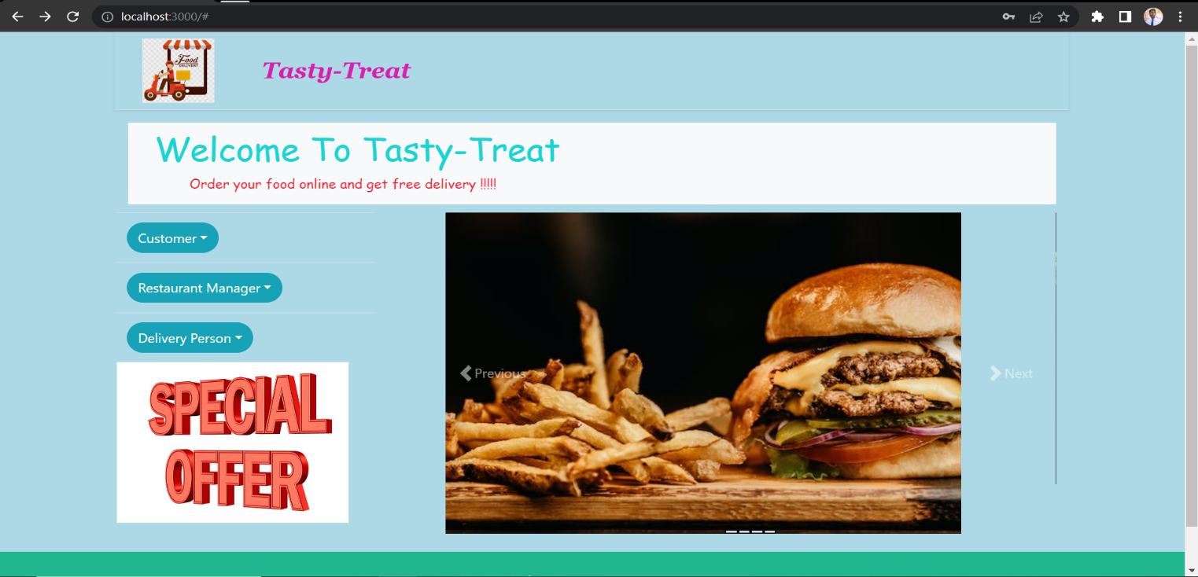

1. **Customer Sign Up Page**

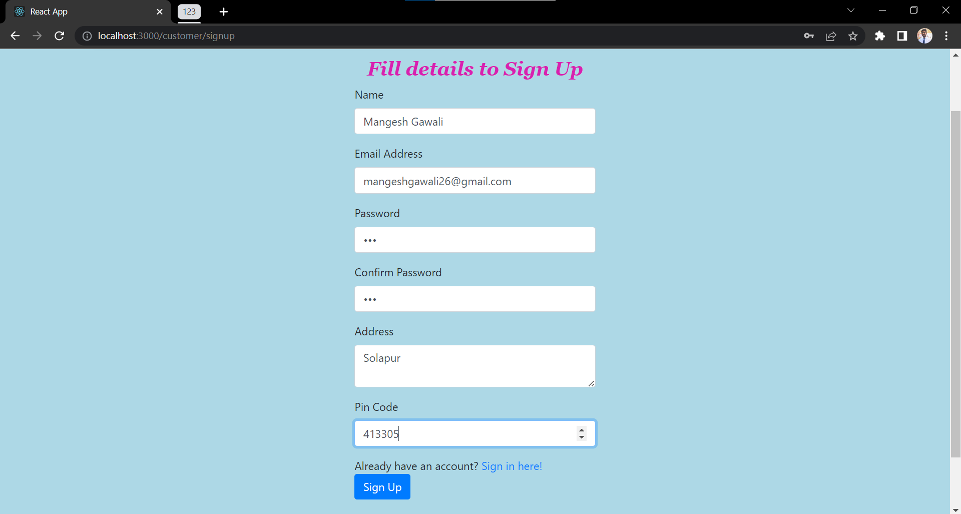

1. **Password Encrypted in Database**

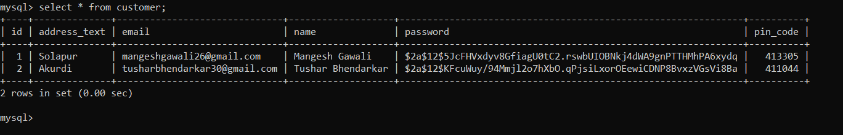

1. **Mail Receive To Customer on Sign Up**

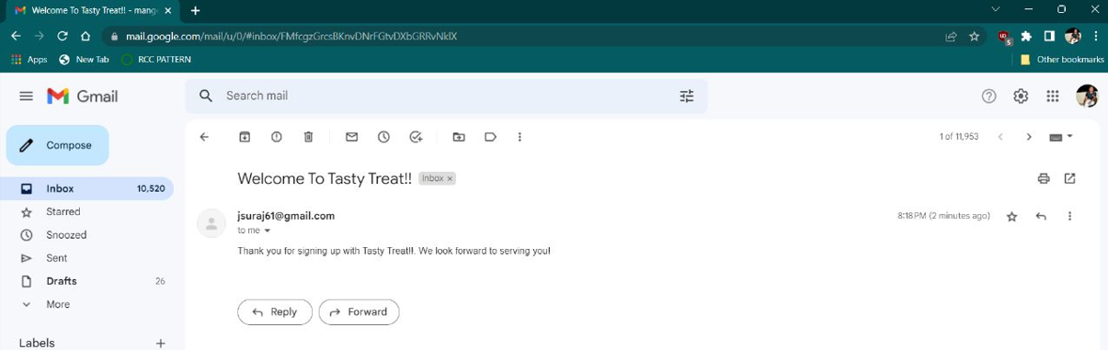

1. **Product added in Cart**

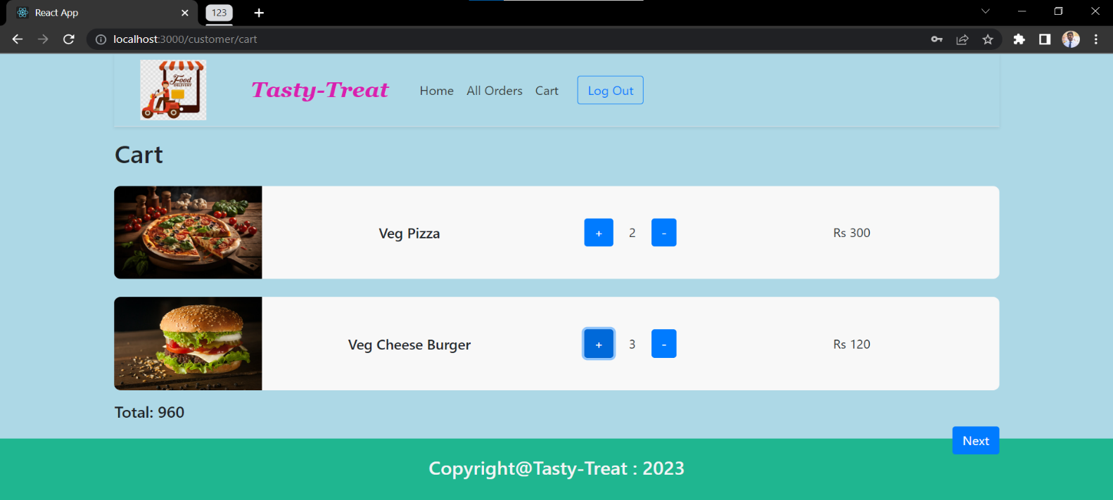

1. **Online Payment after Placing order by customer**

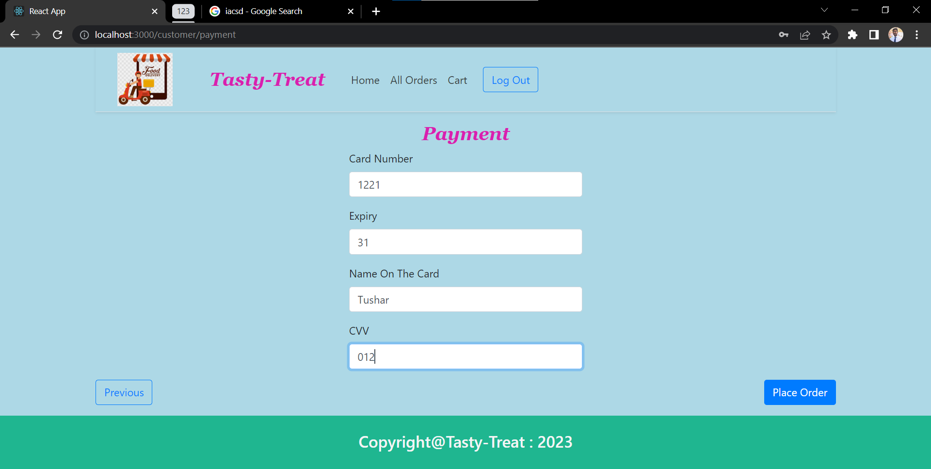

1. **Manager of Restaurant Assigning Delivery**

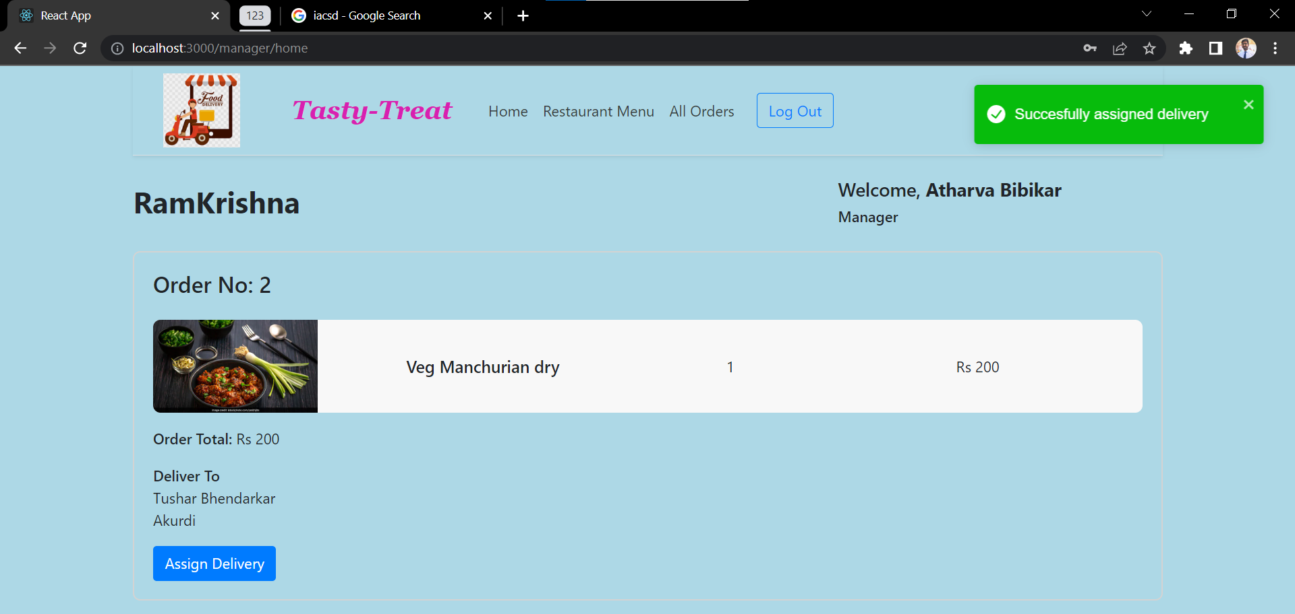

1. **Delivery Pickup and delivered by delivery person with delivery status**

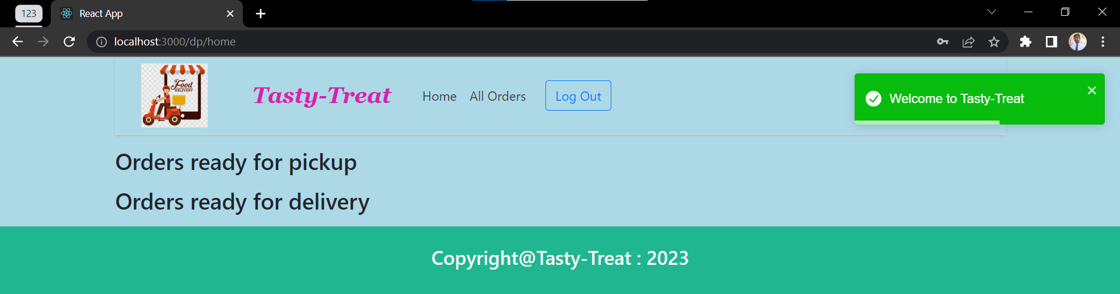

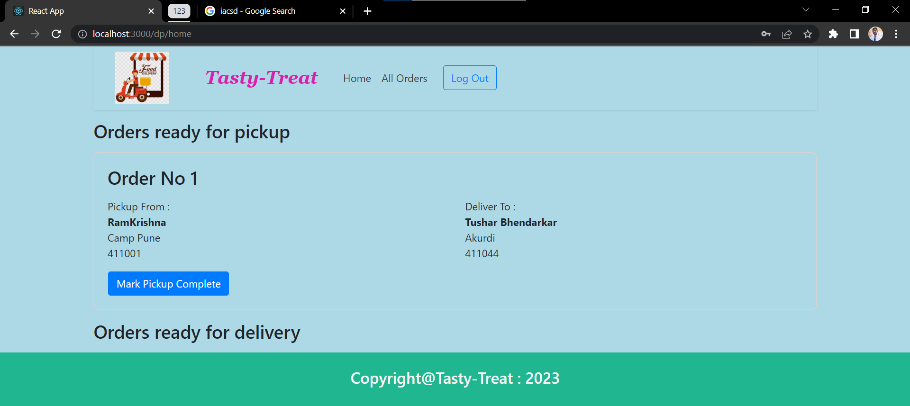

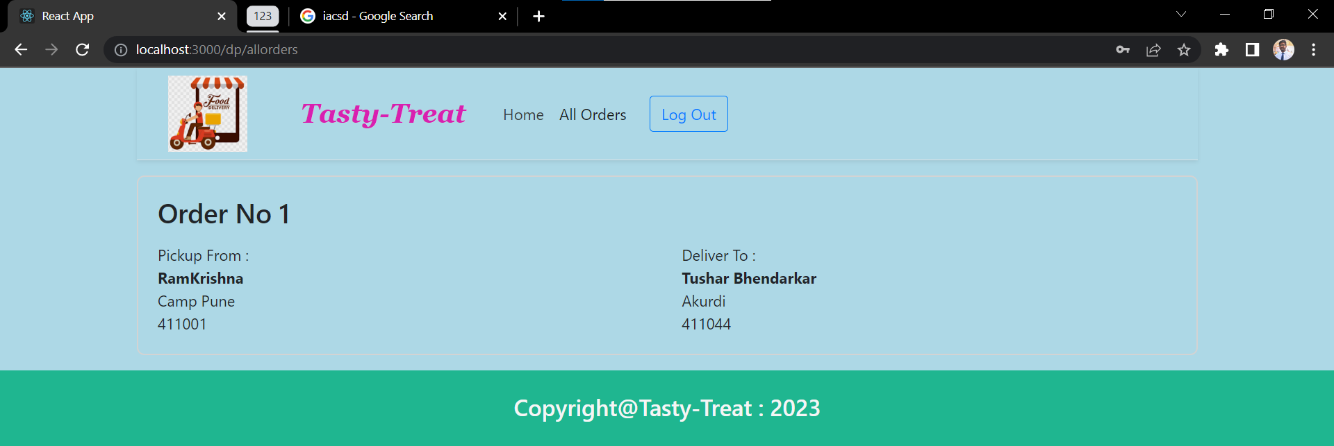

1. **Previous Order Details of Customer**

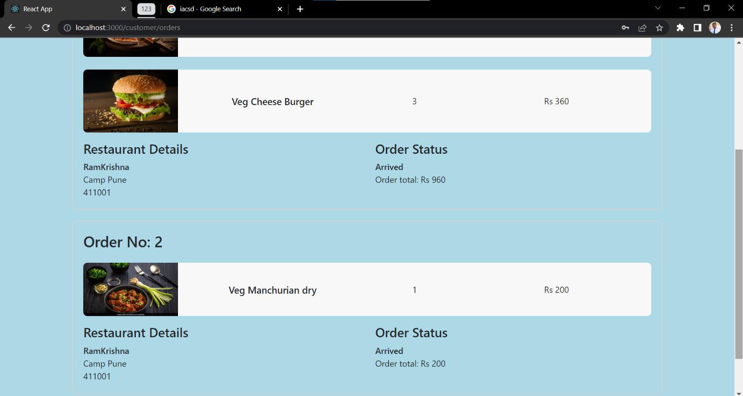

1. **CONCLUSION**

* **Conclusion**

Online food delivery system is process of ordering food through single web portal with access to multiple restaurants at the same time.It provide customers an access to various food items from various hotels and helps to try new foods.It provide restaurant manager to increase the business of their hotel.it also provide home delivery of foods with help of delivery person

This project can later be expanded on a larger scale. It is developed for restaurants to simplify their routine managerial and operational task and to improve the dining experience of the clients. This also helps the restaurant owners develop healthy customer relationships by providing reasonably good services. The system also enables the restaurant to know the items available in real time and make changes to their food and beverage inventory based on the orders placed and the orders completed.

## Future Scope:

This project can be enhanced further by adding payable additional hotels, online feedback system, and local mess for the members to increase the variety of the foods. The software is flexible enough to be modified and implemented as per future requirements.

We have tried our Best to present this free and user–friendly website to customers.

* This Online Food delivery web application can be enhanced further by adding
* live tracking system
* Review and ratings Feedback system for detailed analysis.
* Real time payment system

# REFERENCES.

## References:

## [A Simple E-Commerce Implementation with Spring Baeldung](https://www.baeldung.com/spring-angular-ecommerce)

## [E-Commerce/food delivery app (Zomato/Swiggy/1mg) | by Ravinder Singh Sengar | Medium](https://medium.com/@ravindersengar/end-to-end-design-of-a-food-delivery-app-like-zomato-or-swiggy-52b96f3a635f)

## [Shopping Cart for eCommerce App | Javarevisited (medium.com)](https://medium.com/javarevisited/lets-develop-shopping-cart-for-ecommerce-app-8e57a9ab4868)

## <https://github.com/coniferousdyer/Food-Ordering-Portal>

## [JAVA 11 API Docs](https://docs.oracle.com/en/java/javase/11/docs/api/)

## [J2EE Spring Docs](https://docs.spring.io/spring-framework/docs/3.0.x/spring-framework-reference/html/index.html)